Horizon Europe Framework Programme


OPTICAL 6G CELL FREE NETWORKS

______________________________________________________

D4.2 OWC Localisation Sensing System Construction
Contractual Delivery Date: | 31st December 2025
Actual Delivery Date: | TBD
Editor: (name, organisation) | Bastien Béchadergue, UVSQ
Deliverable nature: | Report
Dissemination level: | Public (PU)
Version: | 1.0
Keywords: Optical wireless communication, cell-free network, radio unit
ABSTRACT
the Construction of the localisation systems
Report on experiments
Beamsteered + RSS localisation
RSS localisation
RDoA localisation

Contributions to Deliverables – 24th November
Completed deliverable - 1st December
Review Comments – 7th December
Deliver to EU - 15th December

Disclaimer
This document contains material, which is the copyright of certain OPTI-6G consortium parties and may not be reproduced or copied without permission.
All OPTI-6G consortium parties have agreed to full publication of this document.
Neither the OPTI-6G consortium, nor a certain part of the OPTI-6G consortium, warrant that the information contained in this document is capable of use, nor that use of the information is free from risk, accepting no liability for loss or damage suffered by any person using this information.

This project has received funding from the European Union’s Horizon Europe research and innovation programme under grant agreement No 101139292. This publication reflects only the author’s view and the European Commission is not responsible for any use that may be made of the information it contains.

Impressum
Full project title: OPTICAL 6G CELL FREE NETWORKS
Short project title: OPTI-6G
Number and title of the work package: WP4 – OWC Localisation Sensing
Number and title of task: Task 4.3 – Integration and Testing of Optical Location Systems
Document title: D4.2 OWC Localisation Sensing System Construction
Editor: Bastien Béchadergue, UVSQ
Work-package leader: John Cosmas, UBRU

Copyright notice
2025 Eurescom GmbH and members of the OPTI-6G consortium

Executive Summary
TBD

List of Authors
Company | Author | Contribution
UBRU | John Cosmas  Kareem Ali  Ali Mahbas | Sections 2 and 4
UVSQ | Bastien Béchadergue  Kevin Acuna-Condori | Sections 1 and 3, editing and formatting

Document History
Version | Date | Editor | Description
0.1 | 28/11/2025 | John Cosmas  Kareem Ali  Ali Mahbas | Inputs to Section 2
0.2 | 01/12/2025 | Bastien Béchadergue | Inputs to Sections 1 and 3
0.3 | TBD | TBD | Final inputs
0.4 | TBD | Bastien Béchadergue | Second round of review and editing
1.0 | TBD | Adam Kapovits | Final editing and submission

Table of Contents
Executive Summary 3
List of Authors 4
Document History 4
List of Figures 7
List of Tables 7
Abbreviations and Acronyms 8
1 Introduction and Objectives 9
1.1 Introduction 9
1.2 Objectives and Structure 9
2 TDoA Localisation System 9
2.1 Reference TDoA Test Results 10
2.1.1 Test Setup 10
2.1.2 On the Move Test 12
2.1.3 Fixed UE Test 13
2.1.4 Handheld UE Test 15
2.1.5 Conclusions 16
2.2 Preliminary Test Procedures 17
2.3 Preliminary Test Results 18
2.3.1 Methodology 18
2.3.2 Overall Positioning Accuracy 19
2.3.3 Distribution of Errors 20
2.3.4 Error Heatmap 21
2.3.5 Precision Analysis and Confidence Intervals 22
2.3.7 95% Mean Confidence Interval 23
2.3.8 Discussion 23
2.3.9 Conclusion 24
3 Beamsteering-Based Localisation System Architecture and Tests 25
3.1 Reminders About Operating Principles 25
3.2 System Architecture 26
3.2.1 Overview of the System Architecture and Implementation 26
3.2.2 Planned Evolution for the Final OPTI-6G Demonstrator 28
3.3 Preliminary Test Procedures 29
3.4 Preliminary Test Results 30
3.4.1 Testbed Parameters 30
3.4.2 Validation of the RSS Acquisition 31
3.4.3 Validation of the 2D Positioning Function 32
3.4.4 Validation of the Positioning Stability With Varying UE Orientation 33
3.4.5 Conclusions 33
4 RSS Localisation System Architecture and Tests 34
4.1 System Architecture 34
4.2 Preliminary Test Procedures 34
4.3 Preliminary Test Results 34
5 Localisation Methods Fusion Using Fingerprinting 34
6 Conclusions and Future Works 34
6.1 Conclusions 34
6.2 Future Works 34
References 35

List of Figures
Figure 1 – Tests setup: overview of the key components 9
Figure 2 – Reference TDoA tests configuration in a stadium 10
Figure 3 – RU antennas deployment in the stadium 10
Figure 4 – Left picture: UE movement trajectory (in white). Right pictures: spectator moving with tracked phone 11
Figure 5 – Measured trajectory 12
Figure 6 – Fixed seat test 12
Figure 7 – Measurements of a UE at a fixed location 13
Figure 8 – Seated user measurements and standard deviation charts 14
Figure 9 – Seated spectator talking with the phone location measurements 15
Figure 10 – TBD 16
Figure 11 – TBD 16
Figure 12: Grid reference GUI 17
Figure 13 – Reference grid points (blue) and calibrated mean positions (orange), with error vectors 19
Figure 14 – Histogram of calibrated mean radial errors showing the distribution of error magnitudes across all grid points. 20
Figure 15 – Error heatmap 21
Figure 16 – 95% mean error confidence interval 22
Figure 17 – Beamsteering-based positioning system geometry and notations 24
Figure 18 – Overview of the beamsteering-based positioning test bench 27
Figure 19 – PCB version of optical antenna including the up/down-converters and the TruPwr™ RSS port 28
Figure 20 – Illustration of the three distinct orientations taken by the optical source of the RU 30
Figure 21 – Voltage samples recorded at the receiver position $r=[0.7, 0.54, 0.75]$ for ten different receiver orientations (represented by different colors), with a random PD tilt ($θ∈[0°,20°]$ and $φ∈[0°,360°]$) 31
Figure 22 – Experimental 2D position estimation of the UE using the proposed beamsteering-based positioning method with SVD estimator 31

List of Tables
Table 1 – Sample of measurement reports obtained in the case of a fixed UE 13
Table 2 – Main development and integration steps of the OPTI-6G system with the corresponding timeline 30

Abbreviations and Acronyms
3GPP | 3rd Generation Partnership Project (3GPP)
5G | Fifth Generation
6G | Sixth Generation
AGC | Automatic Gain Control
AGV | Automated Guided Vehicle
API | Application Programming Interface
CU | Central Unit
dBm | Decibels-milliwatts
DC | Direct Current
DU | Distributed Unit
EVM | Error Vector Magnitude
GDOP | Geometric Dilution of Precision
IF | Intermediate Frequency
LO | Local Oscillator
NIB | Network In a Box
NR | (5G) New Radio
O-RAN | Open-Radio Access Network
OFDM | Orthogonal Frequency-Division Multiplexing
OFE | Optical Front End
OWC | Optical Wireless Communication
OWP | Optical Wireless Positioning
PCB | Printed Circuit Board
PHY | Physical Layer
PIN | Positive-Intrinsic-Negative (Photodiode)
RF | Radio Frequency
RMSE | Root Mean Square Error
RSS | Received Signal Strength
RU | Radio Unit
RX | Receiver
TDoA | Time Difference of Arrival
TIA | Transimpedance Amplifier
TX | Transmitter
UE | User Equipment
UL | Uplink
VCSEL | Vertical Cavity Surface Emitting Laser
WP | Work Package

Introduction and Objectives

Introduction
This deliverable D4.2 is the second deliverable of work package (WP) 4, whose objective is to design, implement, and experimentally validate different optical wireless positioning (OWP) methods that can be used in conjunction with the cell-free optical wireless communication (OWC) system designed as part of WP3.
To achieve this objective, WP4 first focused on proposing and theoretically analyzing three OWP methods based on the use of time difference of arrival (TDoA) and received signal strength (RSS) of signals from different radio units (RUs), as well as on the exploitation of RSS from a single RU whose orientation can be modified using an optical beamsteering system (a method referred to as beamsteering-based positioning).
This theoretical work was detailed in D4.1, along with the proposal to centralize in a localisation server all the estimated positions of the user equipment (UE) obtained with these various OWP methods, in order to eventually obtain a robust and real-time knowledge of the UE’s position.

Objectives and Structure
Following the establishment of these theoretical foundations, the OPTI-6G consortium focused on the practical implementation of the various OWP methods proposed. The main objective of this document is therefore to describe the work that has been undertaken to produce distinct and operational demonstrators enabling initial validation of the various techniques. More specifically, this document details for each technique (TDoA-, beamsteering- and RSS-based OWP) and for the localisation server:
- The architecture of the demonstrator implemented,
- The test procedure followed for initial validation of this demonstrator,
- The results of these initial validation tests.
In practice, this deliverables is structure in four main sections, in addition to this introduction (Section 1) and to the general conclusion (Section 6). Each section is devoted to a specific OWP technique, namely: Section 2 deals with the OWP method based on TDoA, Section 3 with the method based on beamsteering, Section 4 with the method based on RSS, while Section 5 details the work undertaken on the localisation server.

TDoA Localisation System
The implementation and validation of the TDoA positioning method has so far been carried out in the radio domain only, in two stages, as detailed below: first as part of a test campaign conducted in a football stadium (Section 2.1); then as part of a test campaign conducted at the UBRU’s 5G/6G Autonomous IoT Lab, which will host the final OPTI-6G demonstrator (Sections 2.2 and 2.3).

Reference TDoA Test Results
This paragraph describes the results of a UE localization test that was performed in a football stadium with fifth-generation (5G) private network working on the 3.5 GHz microwave air interface in order to serve as a reference and benchmark to the TDoA test to be performed in the OPTI-6G project over the 850 nm optical air interface.

Test Setup
A photo of the test’s setup in RunEL’s lab is presented in Figure 1. This test setup included a 5G system composed of a RunEL RU, a server running the distributed unit (DU), central unit (CU) and 5G core packages supplemented by an application server running the positioning application.
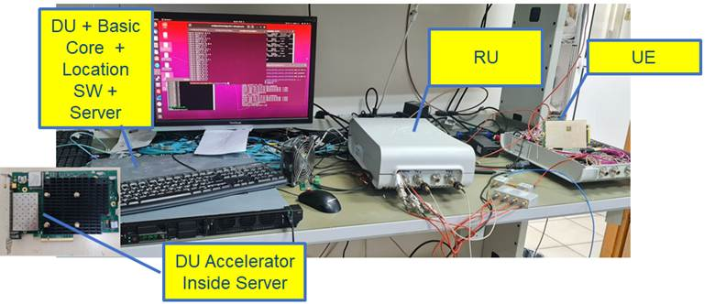
Figure 1 – Tests setup: overview of the key components
In practice, this setup was deployed in a stadium environment, as depicted in Figure 2.

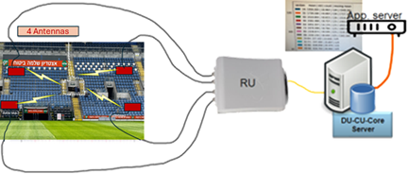
Figure 2 – Reference TDoA tests configuration in a stadium
The RU was connected to four antennas deployed at the stadium’s main tribune as depicted in Figure 3. These four antennas were located at four corners as follows: Antenna 0 at (0.0 m, 18.0 m); Antenna 1 at (19.40 m, 18.00 m); Antenna 2 at (19.40 m, 0.00 m) and Antenna 3 at (0.00 m, 0.00 m). They were thus forming a rectangle of approximately 20 m x 20 m.
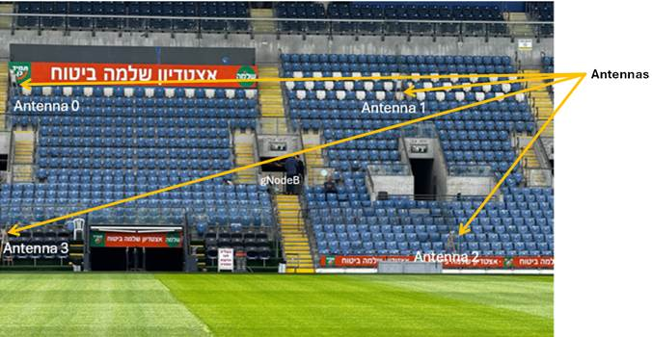
Figure 3 – RU antennas deployment in the stadium
The test procedure followed was as follows:
- Uplink (UL) transmissions from the end terminal are received by 4 antennas connected to the 5G RU.
- The TDoA is measured for each couple of antennas. TDoA measurements are accomplished in picoseconds accuracy using RunEL patented technique.
- Based on hyperbolic trilateration, the UE position is calculated after measurements calibration.
- Measurements calibration is carried out by using a pre-known location UE.
The system, and especially the physical (PHY) layer configuration used for these tests was following 3rd Generation Partnership Project (3GPP) Release 16 (standalone), i.e.:
- Duplexing mode: time division duplexing
- Sub-carrier spacing: 30 kHz
- Channel bandwidth: Up to 100 MHz
- Antenna gain (at the base station): 10 dB / antenna
- Frequency: 3.3-3.8 GHz (band N78)
- $P_{out}$: 21dBm
- Modulation: QPSK REFERENCE SIGNAL
- Beam width of base station antennas: 45° on average +/- 5°
- TTI spacing: 500 µs
- Support for CSI-RS, PTRS, DMRS
- Synchronization: GPS, local clock, external input clock

On the Move Test
A UE was moved manually at this tribune as depicted in Figure 4. This UE was an off-the-shelf Telit990A28 5G end terminal.
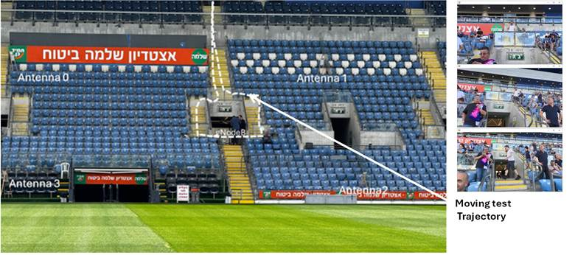
Figure 4 – Left picture: UE movement trajectory (in white). Right pictures: spectator moving with tracked phone
The measured trajectory is depicted in Figure 5. In the corners of the diagram depicted are the antennas, including front end, all connected to the same RU. The point in the middle is a reference point (for calibration).

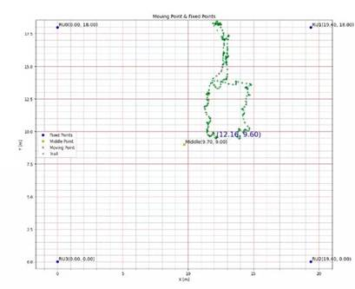
Figure 5 – Measured trajectory

Fixed UE Test
To demonstrate the measurements stability, the UE was left at a point with no movement. The measured location is depicted in Figure 6.
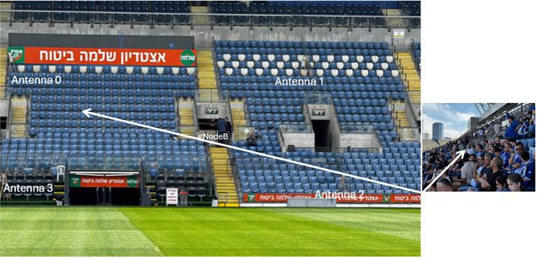
Figure 6 – Fixed seat test
This test was accomplished by repeating the measurement every 20 ms for 25 times. Antennae 0, 2 and 3 were preferred for these measurements’ scenario.
It can be observed from the measurements results file, reproduced in Table 1, that the location coordinates change at both axis ($x$ and $y$) was up to 1 cm.
Table 1 – Sample of measurement reports obtained in the case of a fixed UE
Measurement | Result
1 | (array ([5.15, 9.92]), array ([0, 2, 3]))
2 | (array ([5.15, 9.92]), array ([0, 2, 3]))
3 | (array ([5.15, 9.92]), array ([0, 2, 3]))
4 | (array ([5.14, 9.92]), array ([0, 2, 3]))
5 | (array ([5.15, 9.92]), array ([0, 2, 3]))
6 | (array ([5.15, 9.92]), array ([0, 2, 3]))
7 | (array ([5.14, 9.92]), array ([0, 2, 3]))
8 | (array ([5.14, 9.92]), array ([0, 2, 3]))
9 | (array ([5.14, 9.92]), array ([0, 2, 3]))
10 | (array ([5.14, 9.92]), array ([0, 2, 3]))
11 | (array ([5.14, 9.92]), array ([0, 2, 3]))
12 | (array ([5.14, 9.92]), array ([0, 2, 3]))
13 | (array ([5.14, 9.92]), array ([0, 2, 3]))
14 | (array ([5.14, 9.92]), array ([0, 2, 3]))
15 | (array ([5.14, 9.92]), array ([0, 2, 3]))
16 | (array ([5.14, 9.92]), array ([0, 2, 3]))
17 | (array ([5.14, 9.92]), array ([0, 2, 3]))
18 | (array ([5.14, 9.91]), array ([0, 2, 3]))
19 | (array ([5.14, 9.92]), array ([0, 2, 3]))
20 | (array ([5.14, 9.92]), array ([0, 2, 3]))
21 | (array ([5.14, 9.92]), array ([0, 2, 3]))
22 | (array ([5.14, 9.92]), array ([0, 2, 3]))
23 | (array ([5.13, 9.92]), array ([0, 2, 3]))
24 | (array ([5.13, 9.92]), array ([0, 2, 3]))
The above measurement trajectory is depicted in Figure 7.
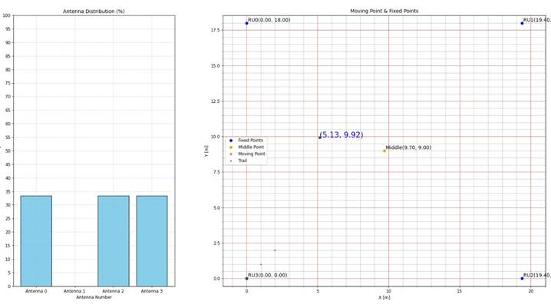
Figure 7 – Measurements of a UE at a fixed location

Handheld UE Test
At another location a similar measurement was repeated while the user was talking with the UE under test. In this case, the UE was slightly moving while the user was seated. The measurements and related trajectory are presented in the Figure 8, whereas the corresponding trajectory is shown in Figure 9.
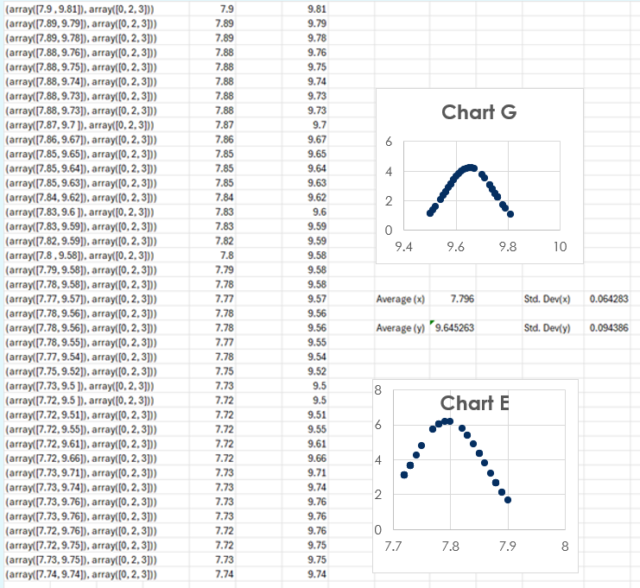
Figure 8 – Seated user measurements and standard deviation charts

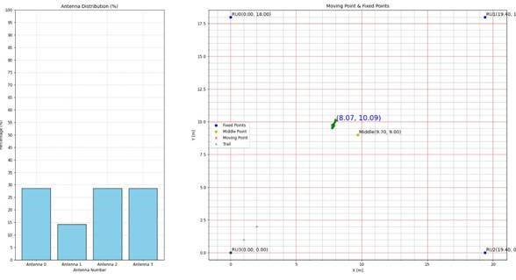
Figure 9 – Seated spectator talking with the phone location measurements
It can be observed (calculated and specified at the right side) that the standard deviation for this case is less than 10 cm which enables accurately to isolate the user’s seat in less than a second).

Conclusions
The conclusions for of these reference tests using 5G signals are that:
- The system operates perfectly in a real-life football stadium environment.
- The UE measured location accuracy was better than 10 cm.

Preliminary Test Procedures
(Note: Setup work with Almog should be added here)
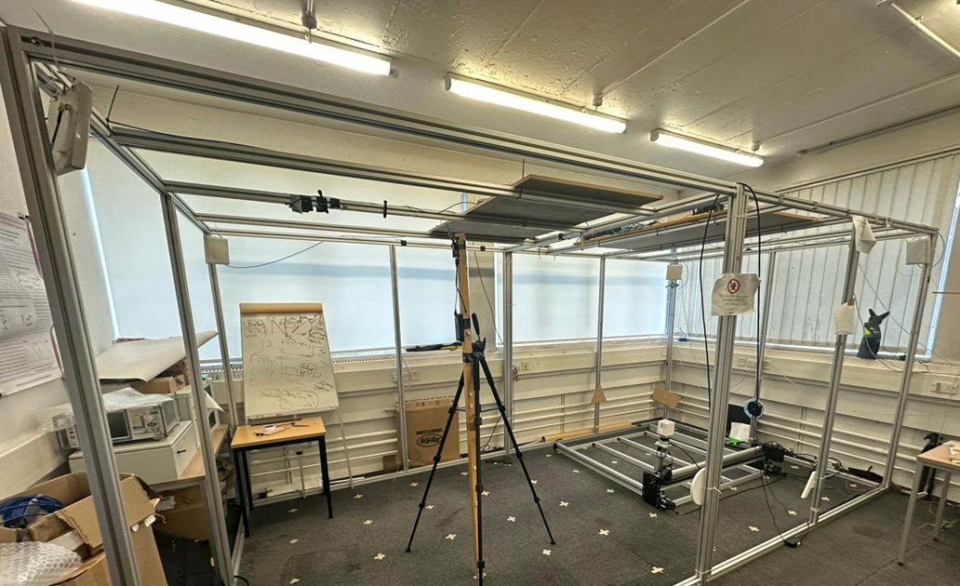
Figure 10 – TBD
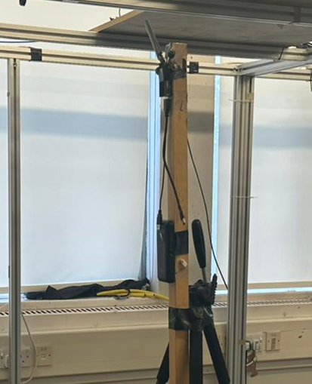
Figure 11 – TBD

Preliminary Test Results
This section presents the evaluation of a 5G based indoor localisation system using a structured 50-point 2D reference grid. Each reference location was sampled 50 times, providing a dataset of 2500 position estimates. The analysis includes radial error, root mean square error (RMSE), standard deviation, spatial accuracy patterns, and 95% confidence intervals. A global calibration procedure was applied to eliminate systematic bias, reducing the overall RMSE from 17.1 cm (uncalibrated) to 14.7 cm (calibrated), representing a 14.2% improvement. The results show stable mid-level accuracy across the grid, with central regions achieving 7–11 cm error and boundary regions experiencing 15–25 cm due to geometric dilution of precision (GDOP). These findings characterise the current performance of the 5G positioning system and identify future refinements required to approach 10 cm accuracy.

Methodology
A structured 5 $×$ 10 reference grid was deployed, spanning approximately 5 m$×$ 2.5 m. The grid, shown in Figure 12, was defined in a local Cartesian coordinate system, and reference points denoted $(x_{r},y_{r})$ were spaced at 50 cm ($u_{x}$-axis) and 25 cm ($u_{y}$-axis). At each of the 50 grid points, 50 independent 5G-based position estimates denoted ($x_{i},y_{i})$ were recorded.
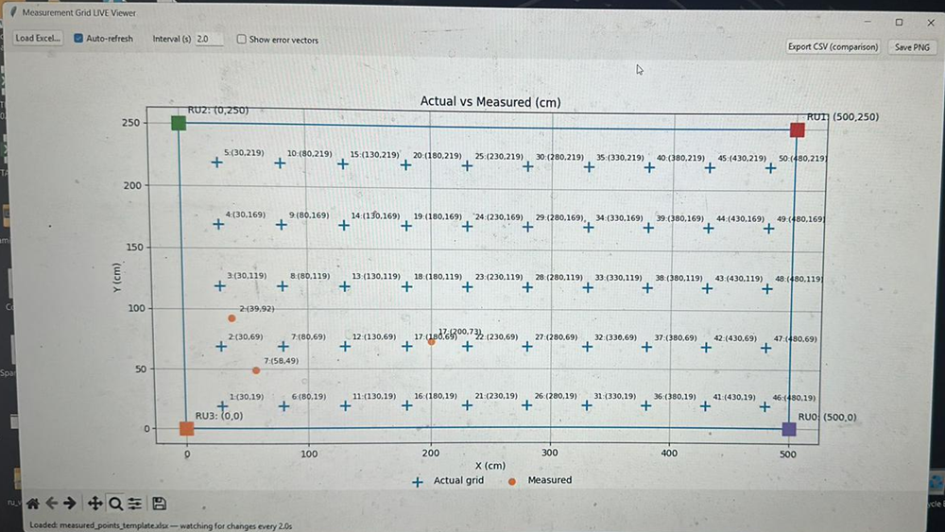
Figure 12 – Grid reference graphical user interface
All raw measurements were converted from metres to centimetres. For each point of coordinates $(x_{r},y_{r})$, the following statistical metrics were computed:
- Mean estimated position: $\overline{x},\overline{y}$
- Radial error per sample: $e_{i}=\sqrt{{\left(x_{i}-x_{r}\right)}^{2}+{\left(y_{i}-y_{r}\right)}^{2}}$
- Mean radial error
- Standard deviation (precision)
- RMSE over all samples
- 95% confidence interval for $\left(x,y\right)$ components: $CI_{95\%}=\frac{1.96σ}{\sqrt{N}}$
A global calibration was applied to reduce systematic bias. A bias vector $Δ=(Δx,Δy)$ was computed as the mean residual offset between all measured and reference points. Each estimate was corrected using:
 | $$\left(x_{i}^{'},y_{i}^{'}\right)=\left(x_{i}-Δx,y_{i}-Δy\right).$$ | (1)
This calibration removes first order errors arising from antenna misalignment, synchronisation offsets, or uncorrected reference frame shifts.
Reference Benchmark Test by RunEL
As part of the broader OPTI-6G activities, RunEL performed an independent reference localisation test using their 5G private network deployed in a football stadium. Their setup consisted of four synchronised antennas arranged in a 20 m × 20 m configuration, with a Telit FN990A28 UE acting as the test device. The evaluation included both fixed UE and handheld scenarios to characterise the short-term stability of their TDoA based positioning engine. The results of this external test serve as a useful benchmark for assessing the expected behaviour of the system prior to conducting our controlled 50-point grid experiment.
Complementary localisation tests conducted independently by RunEL in a football stadium environment demonstrated sub-centimetre jitter for a fixed UE and less than 10 cm variation for handheld usage. These measurements highlight the intrinsic precision and temporal stability of the underlying TDoA engine. The results obtained in our controlled 50-point grid experiment are fully consistent with these observations. Specifically, the calibrated indoor measurements achieve central area errors of 7–11 cm, which fall within the same stability envelope reported by RunEL. Moreover, the increased boundary errors observed in our test (15–25 cm) are expected effects of geometry (GDOP), and do not contradict RunEL’s findings, as their evaluation did not focus on spatial boundary regions. Taken together, both testbeds confirm that the system exhibits predictable and robust localisation behaviour, with our grid analysis providing a more comprehensive accuracy.

Overall Positioning Accuracy
Across the full 50-point grid, the uncalibrated data produced an overall RMSE of 17.1 cm, as computed from the full 2500 sample dataset. After subtracting the estimated global bias (Δx, Δy), the RMSE reduced to 14.7 cm, representing a 14.2% reduction in error.
This means that typical position estimates now fall within approximately one smartphone screen width of the true location, a performance level consistent with mid-precision indoor positioning in multipath rich 5G environments.
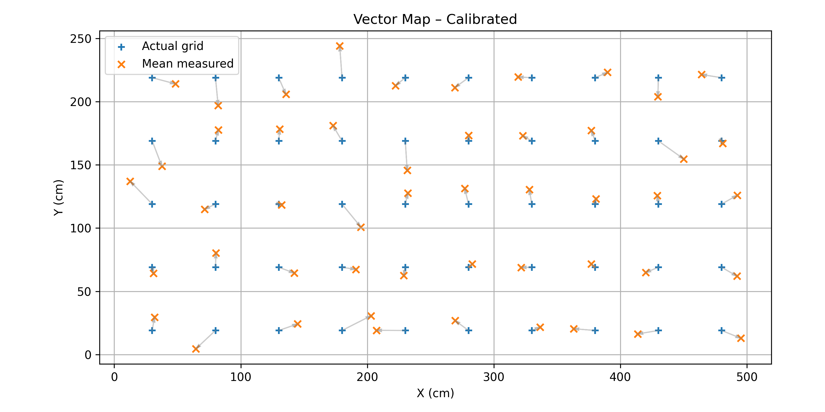
Figure 13 – Reference grid points (blue) and calibrated mean positions (orange), with error vectors
In Figure 13, each arrow depicts the displacement between the calibrated estimate and its corresponding reference point. Most arrows are short and consistently aligned, confirming that calibration successfully removed the global shift present in the uncalibrated results. Accuracy is highest at the centre of the grid, with mean radial errors typically below 10 cm. Larger errors appear at the edges and corners, driven primarily by GDOP and increased multipath intensity near walls and metallic structures. Overall, the vector field demonstrates a stable and uniform localisation field, with predictable degradation only near boundaries.

Distribution of Errors

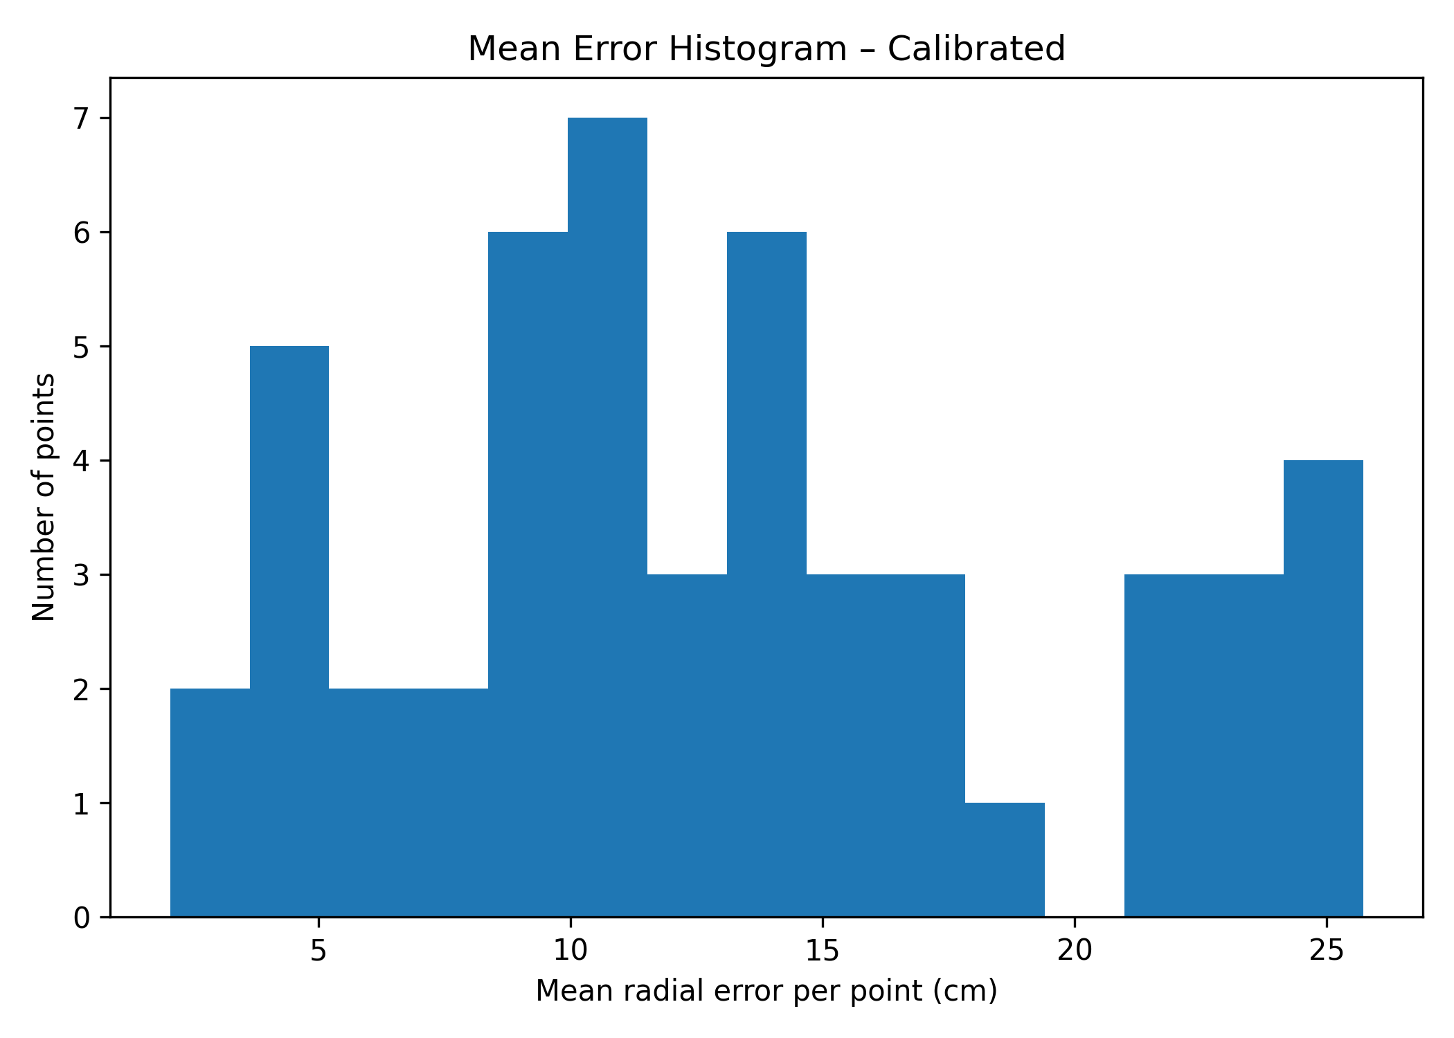
Figure 14 – Histogram of calibrated mean radial errors showing the distribution of error magnitudes across all grid points.
Figure 14 presents the distribution of the calibrated mean radial errors across the 50 point grid. The histogram shows that the majority of grid points cluster tightly within the 8–15 cm range, indicating that the system achieves consistent mid-level accuracy throughout most of the measurement area. A smaller secondary grouping is visible around 18–22 cm, corresponding predominantly to locations near the grid boundaries where anchor geometry and multipath effects degrade accuracy. Importantly, the calibrated results do not exhibit any extreme outliers; no point exceeds approximately 26 cm. This demonstrates that the calibration procedure effectively removed large systematic offsets and compressed the error distribution into a much narrower, more predictable range. Overall, the histogram confirms that the calibrated system behaves in a stable and controlled manner, with most localisation errors falling into lower accuracy bands and very limited spread across the grid.

Error Heatmap
A heatmap was generated to visualise the spatial distribution of mean radial error across the grid. Central grid cells consistently show excellent accuracy (7–11 cm). Outer rows and corner points display higher errors, typically in the 15–25 cm range.
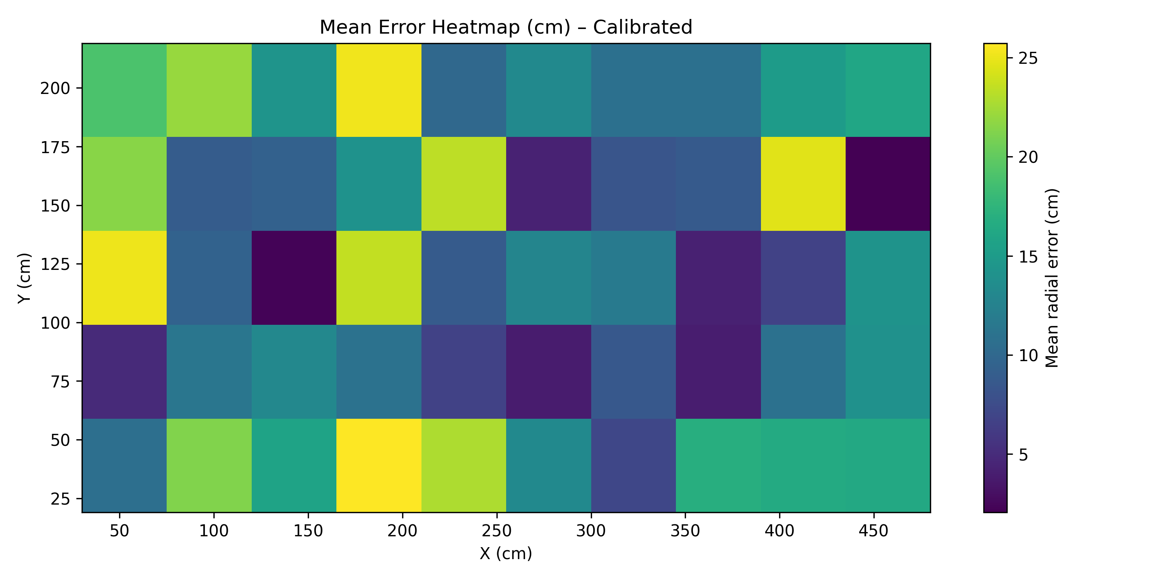
Figure 15 – Error heatmap
This pattern closely follows classical GDOP behaviour, where localisation accuracy degrades as the target moves outside the convex hull formed by the radio anchors. The heatmap therefore reinforces the earlier vector analysis and confirms that anchor geometry, rather than random noise, is the dominant contributor to error variation.

Precision Analysis and Confidence Intervals
Precision was evaluated by analysing the standard deviation of the 50 samples collected at each grid point. Across the entire grid, the system demonstrated consistent repeatability, with typical standard deviations ranging between 4–7 cm, improving to 2–4 cm in the central region where anchor geometry is most favourable. As expected, precision degraded slightly near the boundaries, where standard deviation values increased to 8–12 cm due to GDOP and multipath effects. To further quantify reliability, 95% confidence intervals were computed for the mean estimated coordinates at each point. In the centre of the grid, confidence interval widths were typically within ±1.2–2.8 cm, while boundary points exhibited wider intervals of approximately ±4–5 cm. Overall, these results indicate that the system maintains high statistical stability, with tight confidence bounds even in areas where geometric conditions reduce absolute accuracy.
    - Comparison of Uncalibrated vs Calibrated Performance
A direct comparison of uncalibrated and calibrated performance confirms the benefits of systematic correction. Calibration reduces the overall RMSE by 14.2%, eliminates global positional offsets, and produces a more uniform distribution of errors across the grid. The maximum mean error decreases from roughly 32 cm to 26 cm, and the spread of radial error values becomes narrower and more consistent. Calibration does not alter precision (standard deviation), but it significantly enhances accuracy and interpretability by aligning the measurement field more closely with the reference coordinates.

95% Mean Confidence Interval
Figure 5 illustrates the spatial distribution of the 95% confidence interval (CI) computed for all 50 grid points. Each marker represents a grid location, with the circle size proportional to the CI magnitude derived from the standard deviation of the 50 measurements at that point.
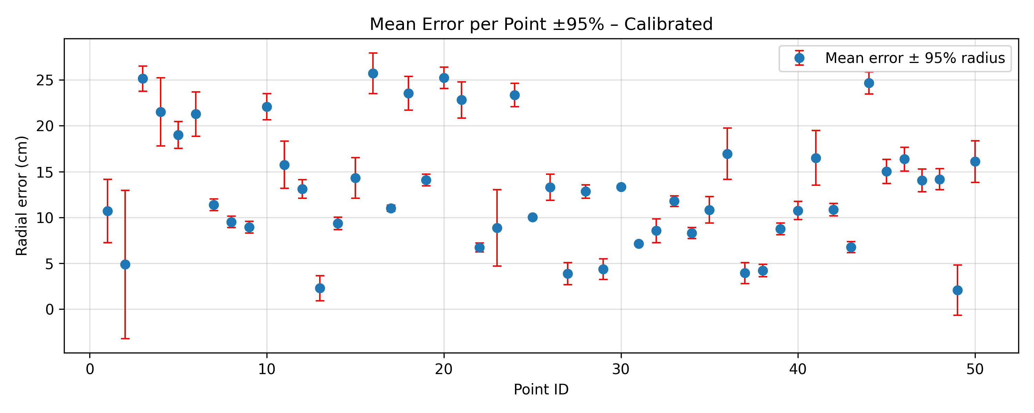
Figure 16 – 95% mean error confidence interval
The figure clearly shows that the central region of the grid exhibits the tightest confidence bounds, typically below ±3 cm, reflecting high measurement consistency and favourable geometric conditions. As expected, the CI radii increase toward the edges and corners, where multipath effects and less favourable anchor geometry lead to reduced precision. These boundary points show CI values in the ±4–5 cm range, yet they remain within a stable and predictable band with no extreme outliers. Overall, the CI visualisation confirms that the system maintains high statistical reliability, with measurement uncertainty staying well bounded across the entire test area, even in regions where absolute error increases.

Discussion
The experimental results demonstrate that the 5G based localisation system delivers robust and predictable indoor positioning performance across a structured measurement grid. The observed accuracy typically 7–15 cm in central regions and 15–25 cm at the edges is consistent with expectations for indoor environments characterised by rich multipath and non-ideal geometry. The system’s strong repeatability, evidenced by narrow confidence intervals, suggests that further improvements may be achieved through enhanced calibration techniques or optimised anchor placement. Future refinements may include multistage calibration, additional reference points, improved antenna configuration, or hybrid positioning strategies that combine 5G measurements with inertial or filtering based approaches.

Conclusion
The 50-point grid evaluation provides a comprehensive assessment of the 5G positioning system’s accuracy and reliability. After global calibration, the system achieves an RMSE of 14.7 cm, with most grid points achieving 15 cm accuracy and central points reaching 10 cm accuracy. The error distributions, precision metrics, and confidence interval analyses all confirm that the system performs consistently and predictably. These findings establish a strong baseline for future system optimisation and support the feasibility of high precision 5G localisation in indoor environments.

Beamsteering-Based Localisation System Architecture and Tests

Reminders About Operating Principles
Figure 17 reminds the geometry of a typical environment where the proposed beamsteering-based positioning solution can be implemented. An optical source, modelled as a Lambertian emitter or order $m$, is placed at point $t={\left[0,0,H\right]}^{T}$ whereas the UE is located at the unknow position $r={\left[x,y,z\right]}^{T}$. The orientation of the optical source, modelled using the orientation vector $n_{t,i}$, may be modified using a mechanical beamsteering platform on which it is installed. For a given direction of the source, the UE is then able to record the corresponding RSS, which also depends on its own position $r$ and on its orientation, noted $n_{r}$.
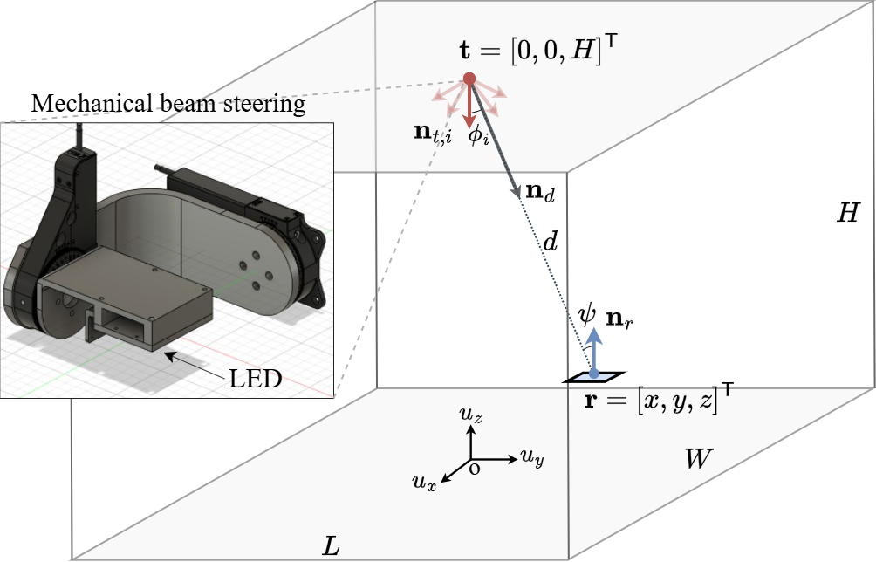
Figure 17 – Beamsteering-based positioning system geometry and notations
Let us assume that the transmitter can take $K$ different orientations, and that for each orientation, the UE records $N$ consecutive samples of the resulting RSS, each disturbed by additive white Gaussian noise (AWGN). We can therefore note these samples $P_{r,i,k}$, with $1≤i≤K$ and $1≤k≤N$. Let us now consider the case of two distinct orientations $i$ and $j$ and define:
 | $${\hat{β}}_{i,j}={\left(\frac{E_{k}\left\{P_{r,i,k}\right\}}{E_{k}\left\{P_{r,j,k}\right\}}\right)}^{\frac{1}{m}},$$ | (3.1)
where $E_{k}\left\{⋅\right\}$ is the expected value of a random variable with respect to the index $k$, i.e., $E_{k}\left\{P_{r,i,k}\right\}$ is the average RSS value measuremd. Then, it can be shown that:
 | $$\left(n_{t,i}-{\hat{β}}_{i,j}n_{t,j}\right)⋅n_{d}=0,$$ | (3.2)
with ‘$⋅'$ the scalar product operator and $n_{d}$ the unit vector supporting the direction from the optical source to the UE (see Figure 17).
This equation alone is not sufficient to estimate $n_{d}$. However, with at least three orientations $i$, $j$ and $k$, we can obtain as estimate ${\hat{n}}_{d}$ of $n_{d}$ by solving the following minimization problem:
 | $${\hat{n}}_{d}=\arg{\min_{\left|\left|n\right|\right|=1}{n^{T}\left(B^{T}B\right)n}},$$ | (3.3)
with $\left\|⋅\right\|$ the Euclidian norm and where:
 | $$B=\left[\begin{matrix}n_{t,i}^{T}-{\hat{β}}_{i,j}n_{t,j}^{T} \\ n_{t,j}^{T}-{\hat{β}}_{j,k}n_{t,k}^{T} \\ n_{t,i}^{T}-{\hat{β}}_{i,k}n_{t,k}^{T}\end{matrix}\right].$$ | (3.4)
Assuming the orientations of the optical sources $n_{t,i}$, $n_{t,j}$ and $n_{t,k}$ are known by the UE, and since the power ratios ${\hat{β}}_{i,j}$, ${\hat{β}}_{i,k}$ and ${\hat{β}}_{j,k}$ are measured by the UE, then the UE can eventually compute ${\hat{n}}_{d}$ by calculating the eigenvector of $B^{T}B$ associated with its minimum eigenvalue $σ_{min}$, according to the Rayleigh-Ritz principle. This is equivalent to obtaining the right singular vector corresponding to $σ_{min}$in the singular value decomposition (SVD) $B=UΣV^{T}$, since the eigenvectors of $B^{T}B$ are the columns of $V$ and their squared eigenvalues are the diagonal elements of $Σ$.
Once ${\hat{n}}_{d}$ is available, the optical antenna can be orientated along ${\hat{n}}_{d}$ whereas the UE can be oriented along $-{\hat{n}}_{d}$ and new RSS samples $P_{r,{\hat{n}}_{d},k}$ can be acquired and averaged by the UE, from which an estimate $\hat{r}$ of the 3D coordinates of the UE $r$ can be obtained using:
 | $$\hat{r} =t+\hat{d} {\hat{n}}_{d}, with \hat{d}=\sqrt{\frac{P_{t}\left(m+1\right)A_{r}}{2πE_{k}\left\{P_{r,{\hat{n}}_{d},k}\right\}}},$$ | (3.5)
with $P_{t}$ the optical power transmitted by the source and $A_{r}$ the sensitive area of the PD used by the UE.
This method, next referred to as the SVD estimator, supports not only 2D positioning but also 3D positioning and is therefore an improved version of the technique proposed in D4.1, which only supported 2D positioning with a single steerable source. Note that more advanced estimators of ${\hat{n}}_{d}$ have also been proposed and studied but they are out of the scope of this deliverable.

System Architecture

Overview of the System Architecture and Implementation
The architecture of the beamsteering-based localisation system has been initially described in D4.1 (Section 5.4) and then complemented in D2.3 (Section 1.4.3). It is reminded here to facilitate the reading of this deliverable. Note that this architecture can support any estimator of ${\hat{n}}_{d}$, especially the SVD estimator which has been used in the preliminary tests then reported in Section 3.4.
Figure 18 shows the core components of the beamsteering-based positioning demonstrator, which has been deployed at USVSQ and will later be integrated to the OPTI-6G system at UBRU’s 5G/6G Autonomous IoT Lab. This demonstrator relies on the infrastructure side on the RU’s optical antenna ① operating so as to enable both cell-free communication and positioning. Note that the component ① in Figure 3.2 is a simple LED (OSRAM LED LZ1-00R702) shown to illustrate the overall implementation of the testbed, but this will be replaced by an actual RU’s optical antenna in the final demonstrator. Note also that in practice, the type of signal sent by this optical antenna does not matter, as only its continuous part is exploited.
This optical antenna is installed on a custom-made beamsteering stage ②, itself fixed to a bracket ③ at given height. This stage is designed to control the orientation of the antenna’s optical axis with two rotational degrees of freedom. It consists of two orthogonal Thorlabs PRMTZ8/M motorized precision rotation stages ④, controlled themselves by the localisation server ⑤ (here a computer for illustration) via Thorlabs KDC101 servo motor controllers ⑥. In practice, these rotation stages control the orientation of a platform that enables fixing optical antennas with variable form factors while keeping their optical source at the center of rotation of the beamsteering stage and avoiding physical obstructions of the optical signal when changing the orientation.
On the other end of the link, the UE’s optical antenna ⑦ (here a custom-made optical receiver based on an OSRAM BPX61 silicon PIN PD) is attached to the gripper of a Universal Robots URS robot arm ⑨, which position and orientation can be controlled by a test computer ⑤ (here the same computer as that used the control the orientation of the RU’s optical antenna, but which will be separate from the localisation server in the final demonstrator). The UE’s optical antenna are directly used to capture the RSS of the signals received from the different orientations of the RU’s optical antenna and then compute the UE’s localisation, using the process described in Section 3.1. Once estimated, the UE’s position will be sent by the UE itself to the RU and therefore to the localisation server via the RU-UE OWC link. However, if necessary, an additional external RSS reader (e.g., the voltmeter ⑧) can be connected to the UE’s optical antenna to get another RSS measure and then compute the UE’s localisation from an external device, such as the computer ⑤.

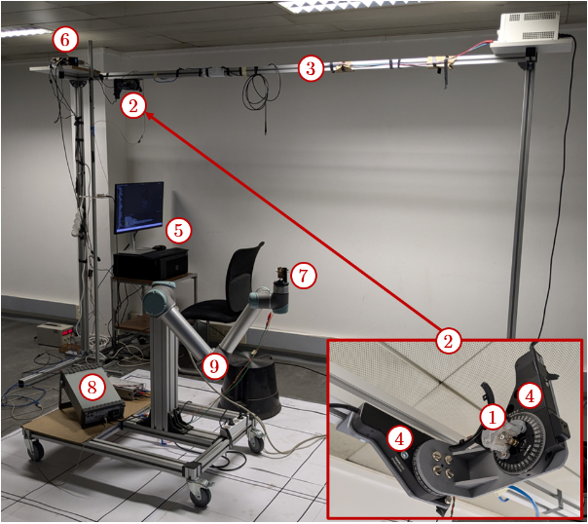
Figure 18 – Overview of the beamsteering-based positioning test bench

Planned Evolution for the Final OPTI-6G Demonstrator
In this deliverable, the results reported were obtained with custom antennas used as RU and UE, and with the position estimation only made at the UE level, without any feedback loop to the RU via a communication link between the UE and RU. However, in its final version, this demonstrator will integrate the optical antennas designed by OLED and integrating the up/down-converters, as shown in Figure 19 and further described in Sections 3.2 and 3.3 of D3.2. In particular, the AD8361 TruPwr™ output port will be used on the UE side to collect the RSS values for each orientation of the RU’s optical antenna, that will then be processed to retrieve the UE’s localisation, whereas the OWC link will be used to send the resulting position estimates.
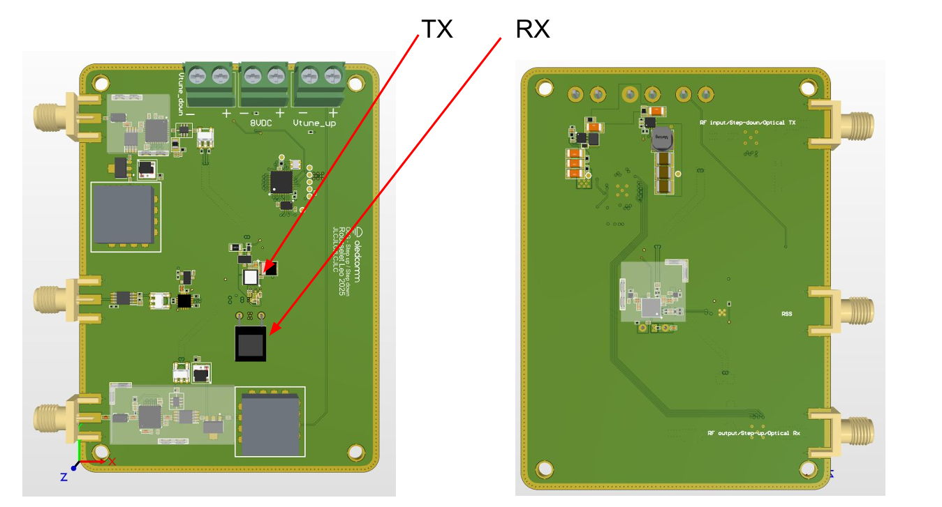
Figure 19 – PCB version of optical antenna including the up/down-converters and the TruPwr™ RSS port

Preliminary Test Procedures
The detailed test plan that will be put in place to validate the proposed beamsteering-based positioning technique when integrated in the full OPTI-6G system will be detailed in D4.3, but a preliminary version of this plan is proposed here, based on the preliminary validation tests that have been carried out using the test bench described in Section 3.2.
The purpose of these preliminary tests was to investigate the accuracy, latency and positioning coverage of the proposed beamsteering-based localisation method, in line with the procedure proposed in D2.3. However, the sensitivity to changes in orientation of the UE has also been tested, which is new compared to the procedure described in D2.3. The updated test procedure eventually followed is thus as follows:
- The UE is positioned at a given known location $r_{m,l}=(x_{m,l},y_{m,l},z_{m,l})$, with $1≤m≤M$, $1≤l≤L$, $M$ the total number of UE positions tested, and $L$ the total number of UE orientations tested.
- This UE is also set to have a known orientation $n_{r,l}$.
- At this location and for this UE orientation, the RU’s optical antenna is oriented in a known direction $n_{t,i}$ and transmits a signal containing a continuous part. The UE’s optical antenna then measures the corresponding RSS (either with a dedicated device such as ⑧ in Figure 18, or directly via the TruPwr™ port of the optical antenna in the envisioned final version of the demonstrator). In practice, $N$ consecutive values of RSS are recorded.
- Step 2 is then repeated $K$ times for $K$ different orientations of the RU’s optical antenna. For a given location and orientation of the UE, $N×K$ RSS samples are therefore collected.
- Once the UE has collected these $N×K$ RSS samples, noted ${\left\{P_{r,i,k}^{m,l}\right\}}_{\begin{aligned}1≤i≤K \\ 1≤k≤N\end{aligned}}$, it processes them using the SVD estimator detailed in Section 3.1, in order to obtain with (3.3) an estimation ${\hat{n}}_{d,m,l}$ of the direction pointing from the optical source toward the UE. At the same time, a timer is used to determine the latency of this direction estimation step.
- Both the RU’s optical antenna and the UE’s optical antenna are then re-oriented toward ${\hat{n}}_{d,m,l}$ and $-{\hat{n}}_{d,m,l}$ respectively, and the UE captures $N$ samples of RSS ${\left\{P_{r,{\hat{n}}_{d},k}^{m,l}\right\}}_{1≤k≤N}$ in this configuration.
- These samples are finally exploited to recover the UE’s coordinates using (3.5), and thus get the estimate ${\hat{r}}_{m,l}=({\hat{x}}_{m,l},{\hat{y}}_{m,l},{\hat{z}}_{m,l})$. At the same time, a timer is used to determine the latency of this coordinates estimation step.
- The resulting estimated coordinates are compared with the actual coordinates to obtain the positioning error $e_{m,l}=\left\|{\hat{r}}_{m,l}-r_{m,l}\right\|$, with for the given position and orientation of the UE.
- In parallel, the sum of the direction finding (Step 5) and coordinate estimation (Step 7) latencies is computed for each test position and orientation of the UE.
- Steps 2 to 9 are then repeated for any other orientation of the UE under test, with $L$ the total number of orientations tested. Note that in case the study of the sensitivity to the UE’s orientation is not necessary, this step may be skipped.
- Steps 1 to 10 are then repeated for any other location of the UE under test, with $M$ the total number of positions tested.
- At the end of this Step 11, we thus obtain the collection of positioning errors ${\left\{e_{m,l}\right\}}_{\begin{aligned}1≤m≤M \\ 1≤l≤L\end{aligned}}$, which can be further processed to extract positioning error statistics. For example, we can calculate:
  - The global RMSE, using:
 | $$RMSE_{global}=\sqrt{\frac{1}{ML}\sum_{m=1}^{M}{\sum_{l=1}^{L}{e_{m,l}^{2}}}}.$$ | (3.6)
  - The average positioning error:
 | $$APE=\frac{1}{ML}\sum_{m=1}^{M}{\sum_{l=1}^{L}{e_{m,l}}}.$$ | (3.7)
  - The empirical cumulative distribution function (CDF) of all the obtained errors (either for a given orientation of the UE or for all orientations of the UE), from which the accuracy metric $ε_{P\%}$ can be extracted. This metric defines the threshold under which $P$% of the obtained positioning errors remain, e.g., the median if $P=50$ of the 90-th percentile if $P=90$.
  - The pooled within-position root mean square radius (WRMS), using:
 | $$WRMS=\sqrt{\frac{\sum_{m=1}^{M}{\sum_{l=1}^{L}{{\left\|{\hat{r}}_{m,l}-{\overline{r}}_{m}\right\|}^{2}}}}{M(L-1)}} with {\overline{r}}_{m}=\frac{1}{L}\sum_{l=1}^{L}{{\hat{r}}_{m,l}}.$$ | (3.8)
This metric enables us to quantify pure repeatability under UE orientation changes.
- In parallel, the average latency is calculated. By construction, this latency excludes the time needed to change the orientation of the optical source, given that the mechanical beamsteering system designed and implemented has not been optimized in terms of steering speed. This explains why the average latency is referred to as the average extra-latency below.
It may be noted that in the case of 2D positioning only, Steps 6 and 7 are not necessary, as the coordinates $x$ and $y$ can directly be deduced from ${\hat{n}}_{d,m,l}$ and the known vertical distance between the RU and the UE.

Preliminary Test Results

Testbed Parameters
Using the testbed described in Section 3.2 and following the process described in Section 3.3, we have performed preliminary tests for 2D positioning of a UE with a single steerable optical antenna at the RU level. As detailed in Table 2, these tests have been performed over a 0.8 $×$ 0.8 m² planar workspace, using the three RU’s orientations illustrated in Figure 20. For each position and orientation of the UE, and each orientation of the RU, 10³ voltage samples were acquired. The robotic arm was positioned at 18 random locations within the $u_{x}$-$u_{y}$ workspace. For each ground-truth location, ten independent runs were performed with random receiver tilt $(θ_{r}∈[0°,20°]$) and random azimuth $(φ_{r}∈[0°,360°]$), keeping the optical source of the RU within its FOV.
Table 2 – Main development and integration steps of the OPTI-6G system with the corresponding timeline
Parameter | Value
Workspace dimensions | 0.8 $×$ 0.8 m²
Number of RU’s orientations ($K$) | 3
RU’s orientations in spherical coordinates ($n_{t,i}=[θ_{t,i},φ_{t,i}]$) | - Orientation 1 : $θ_{t,1}$ = 20°, $φ_{t,1}$ = 0°  - Orientation 2 : $θ_{t,2}$ = 20°, $φ_{t,2}$ = 120°  - Orientation 3 : $θ_{t,3}$ = 20°, $φ_{t,3}$ = 240°
Number of recorded samples per RU’s and UE’s orientations and positions ($N$) | 10³
Number of UE’s positions tested ($M$) | 18
Number of random UE orientations tested ($L$) | 10
Random PD tilt range in spherical coordinates ($n_{r}=[θ_{r},φ_{r}]$) | $θ_{r}∈[0°,20°]$ and $φ_{r}∈[0°,360°]$
Total number of collected RSS samples | 5.4 $×$ 10⁵

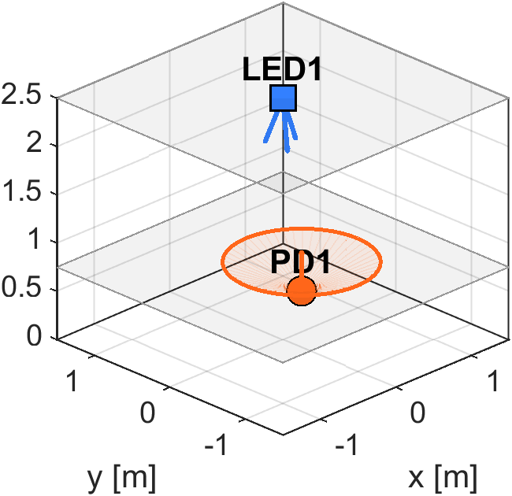
Figure 20 – Illustration of the three distinct orientations taken by the optical source of the RU

Validation of the RSS Acquisition
First, we verified that the RSS values collected by the UE were stable over time and how they varied with the orientation of the source and of the UE. The resulting traces at one representative position ($r=[0.7, 0.54, 0.75]$) are shown in Figure 21. Each sub-figure corresponds to a source orientation, whereas each colour corresponds to a given UE orientation. We can clearly see the variability of the RSS with these orientations, reflected by the different plateaus, while the intra-plateau variability reflects noise.
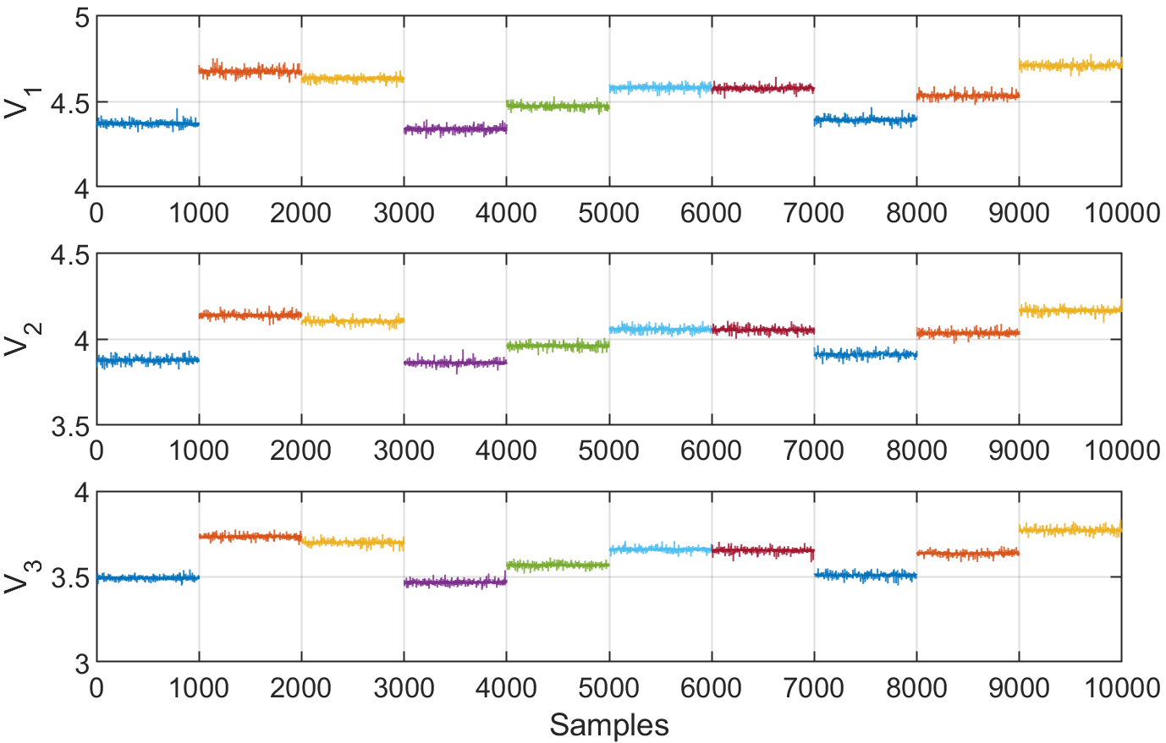
Figure 21 – Voltage samples recorded at the receiver position $r=[0.7, 0.54, 0.75]$ for ten different receiver orientations (represented by different colors), with a random PD tilt ($θ∈[0°,20°]$ and $φ∈[0°,360°]$)

Validation of the 2D Positioning Function
Two–dimensional position estimates obtained with the SVD estimator have then been computed. Figure 22 shows in the workspace plane the ground-truth positions (in blue) and the resulting estimated positions (in green). Each cluster of estimated positions around a ground-truth position corresponds to the ten different estimates obtained from the ten different orientations of the UE.
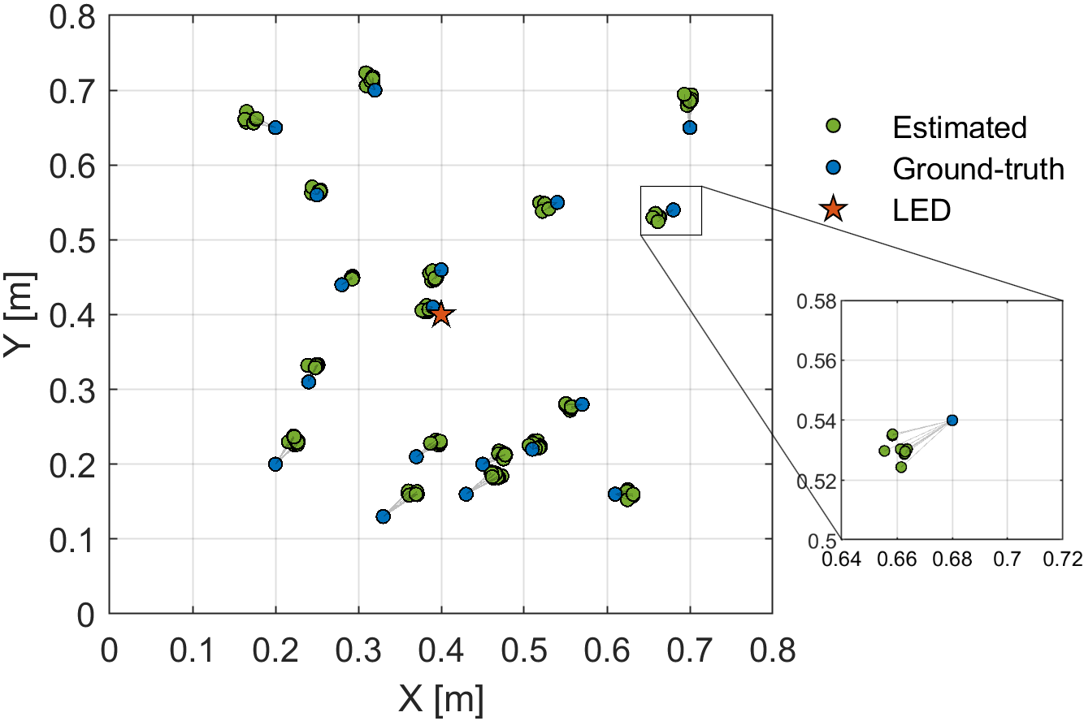
Figure 22 – Experimental 2D position estimation of the UE using the proposed beamsteering-based positioning method with SVD estimator
From these tests, we can deduce that across all tested locations and orientations of the UE:
- The ${RMSE}_{global}$ is 2.66 cm, the $APE$ is 2.35 cm, and the 90-th percentile error $ε_{90\%}$ is 4.32 cm, which is in line with the target accuracy KPI of 5 cm proposed in D2.3.
- In addition, the $WRMS$ is 4.8 mm, indicating sub-centimetric dispersion of repeated estimates at each location despite random receiver tilts up to 20°.
- In parallel, it may be noted that the average extra-latency was measured in the range of a few ms, well below the 20 ms targeted in D2.3, although this value obviously depends on the computing power of the device used for estimation (here a computer).
- Finally, the tested coverage remains according to these preliminary tests at 0.8 $×$ 0.8 m², which is below the 4 m² targeted in D2.3. This difference is however not identified as a system limitation, but simply results from a choice made to limit the duration of the preliminary tests phase.

Conclusions
The experimental results presented here confirm that the proposed beamsteering-based positioning method is experimentally operational for 2D positioning, with performance in line with the expectations listed in D2.3 (see Section 3.4.3 for more details). They also demonstrate that this method has a limited sensitivity to variations in the UE orientations, which is a valuable advantage over conventional RSS methods relying on multiple and distinct optical sources.
These preliminary tests are therefore promising for the integration of the proposed beamsteering-based positioning technique into the final OPTI-6G demonstrator. The steps remaining to be validated for this integration have been identified in Section 3.2.2. Once this integration will be completed, the test reported here will need to be reproduced and then extended to 3D positioning in order to completely validate the method. In addition, machine learning (ML) methods will be used to further improve the positioning performance. Examples of test results with ML estimators in 2D have already been reported in Section 3.2.3 of D2.3, and open the way to promising performance improvements if extended to 3D and combined with the estimators currently under study.

RSS Localisation System Architecture and Tests

System Architecture

Preliminary Test Procedures

Preliminary Test Results

Localisation Methods Fusion Using Fingerprinting

Conclusions and Future Works

Conclusions
This deliverable D4.2 details the work carried out by the OPTI-6G consortium to independently implement and test the various OWP methods that will be integrated into the project’s final demonstrator, namely the TDoA-, beamsteering-, and RSS-based methods, as well as their integration into a localisation server. Several key achievements can be extracted from this document. More precisely:
- Regarding the TDoA-based OWP method, the key achievements are…
- Regarding the beamsteering-based OWP method, the key achievements are the implementation of a full and operational demonstrator that includes a mechanical beamsteering solution to change the orientation of the optical source of the RU. This demonstrator has been partially validated, demonstrating a 2D positioning error below 5 cm with a very low sensitivity to changes in the UE orientation and an extra-latency of a few ms, in line with the KPI targeted in D2.3.
- Regarding the RSS-based OWP method, the key achievements are…
- Finally, regarding the localisation server, the key achievements are …

Future Works
Now that each positioning brick has been independently and partially validated, WP4 will be able to focus on integrating these different functions into the final OPTI-6G demonstrator, which should enable cell-free OWC in parallel with cm-level accuracy OWP of the UE. From the perspective of each OWP technique, this means more specifically that:
- Regarding the TDoA-based OWP method, future works include…
- Regarding the beamsteering-based OWP method, future works mainly include the replacement of the custom-made optical antennas by the optical antennas designed by OLED for OWC and including a TruPwr™ port for real time RSS measurement. Once integrated, the resulting demonstrator will need to be validated not only for 2D but also for 3D positioning, according to the KPI listed and targeted in D2.3.
- Regarding the RSS-based OWP method, future works include…
- Finally, regarding the localisation server, future works include…

References
[OPT2024] OPTI-6G Consortium (2024). Near IR Cell Free Communication System Design. Deliverable D3.1, Version 2.0. EU-funded project (Grant Agreement No. 101146954). April 22, 2024.
[AD25] Analog Devices (2015). AD8361: TruPwr Detector, 2.5 GHz, 65 dB Logarithmic Detector. Datasheet, Revision D. July 2015. Available at: https://www.analog.com/media/en/technical-documentation/data-sheets/ad8361.pdf.

